Sales Performance & Customer Analytics
Complete Project Report & Technical Documentation
Prepared: July 2026 | Data period: Jan 1 - Apr 9, 2024 | Sources: sales_data.csv, customer_churn.csv

Contents
- Part A - Project Report: Problem Definition, Data Preparation, EDA, Customer Analysis, Sales Trends, Pivot Tables, Retention, Visualizations, Recommendations, Executive Summary
- Part B - Technical Documentation: Setup Instructions, Code Structure, Technical Requirements Mapping, Visual Documentation (Screenshots), Testing Evidence

PART A — PROJECT REPORT

1. Problem Definition
The business needs a clear view of who its customers are, how much they are worth, which products and regions drive revenue, and whether purchasing activity is linked to customer retention. This report analyzes 100 sales transactions recorded between January and April 2024 alongside a 500-record customer churn dataset to answer four questions:
- Who are the highest-value customers, and what is their estimated lifetime value?
- Which products and regions generate the most revenue, and how does revenue trend month over month?
- What is the customer retention rate, and does it vary by contract type?
- What actions should the business take based on these findings?

2. Data Collection & Preparation
Two files were used: a transactional sales extract (100 rows: Date, Product, Quantity, Price, Customer ID, Region, Total Sales) and a customer churn file (500 rows: Tenure, Monthly Charges, Total Charges, Contract, Payment Method, Paperless Billing, Senior Citizen flag, Churn flag).
Data quality checks found no missing values and no duplicate rows in either file, though a defensive cleaning step (median-fill for numeric columns, mode-fill for categorical columns) was included in the pipeline for robustness against future data refreshes.
The two files use different customer ID formats (e.g. "CUST001" vs "C00001"), but both encode the same underlying numeric key. Extracting that key allowed the two datasets to be merged, revealing that the 100 transacting customers are a subset of the full 500-customer base. Additional calculated fields were engineered: transaction month, weekday, and a validation column confirming Total Sales equals Quantity times Price for all records.

3. Exploratory Data Analysis
Across the observed period the business recorded ₹12,365,048 in total revenue from 100 orders, an average order value of approximately ₹123,650. Revenue was recorded across 5 product lines (Laptop, Tablet, Phone, Headphones, Monitor) and 4 regions (North, South, East, West).
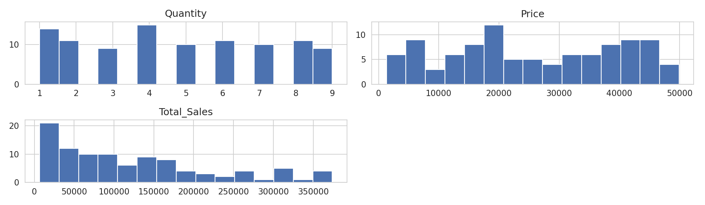
Figure 1. Distributions of Quantity, Price, and Total Sales.
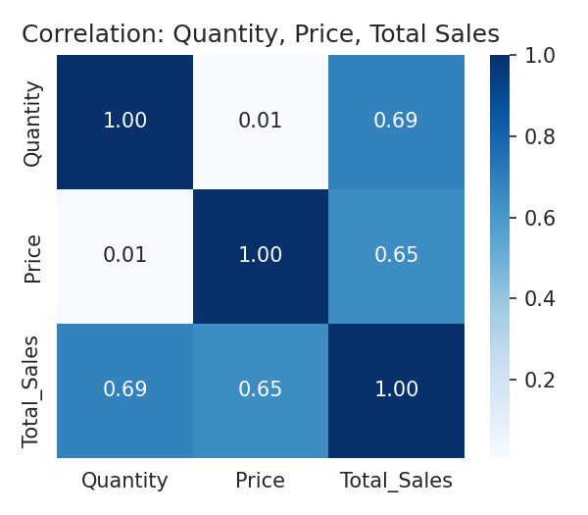
Figure 2. Correlation between Quantity, Price, and Total Sales.

4. Customer Analysis: Top Customers & Lifetime Value
The table below shows the five highest-spending customers by total transaction value:
Rank | Customer ID | Total Revenue
1 | CUST016 | 373,932
2 | CUST007 | 363,870
3 | CUST083 | 350,888
4 | CUST073 | 349,510
5 | CUST020 | 333,992

Because each customer in the sales extract completed a single recorded transaction, lifetime value was estimated by combining transaction revenue with churn-file tenure and monthly charges (Estimated CLV = Monthly Charges x Tenure) for the matched customers. This gives a directional CLV estimate until multi-purchase history is captured.
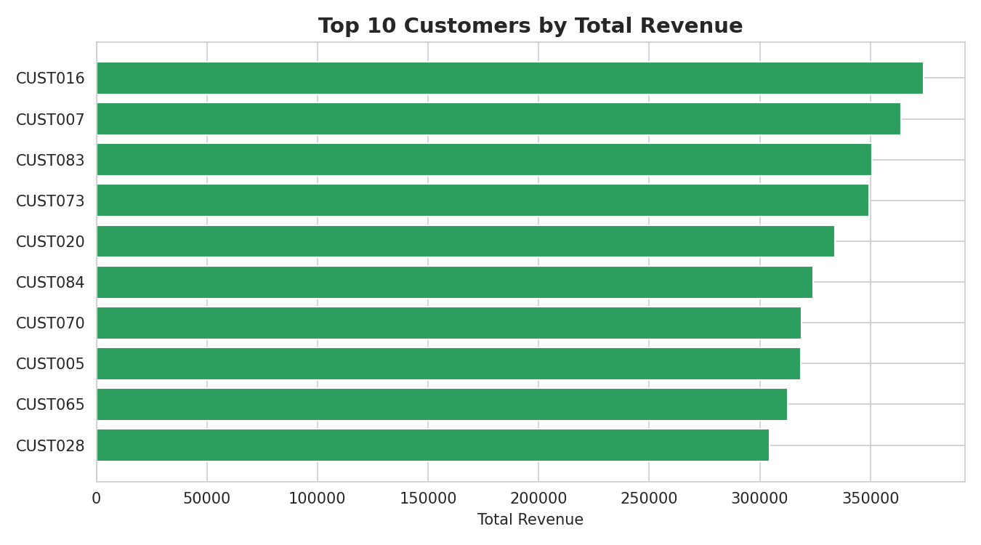
Figure 3. Top 10 customers by total revenue.

5. Regional Distribution
Revenue by region, highest to lowest:
Region | Total Revenue | Share of Total
North | 3,983,635 | 32.2%
South | 3,737,852 | 30.2%
East | 2,519,639 | 20.4%
West | 2,123,922 | 17.2%

North and South together generate over 62% of total revenue, while West is the weakest-performing region at 17.2% of revenue.

6. Monthly Sales Trend & Best-Selling Products
Monthly revenue peaked in March 2024 and dipped sharply in the partial data available for April:
Month | Total Revenue
Jan 2024 | 4,120,524
Feb 2024 | 2,656,050
Mar 2024 | 4,485,006
Apr 2024 (partial) | 1,103,468

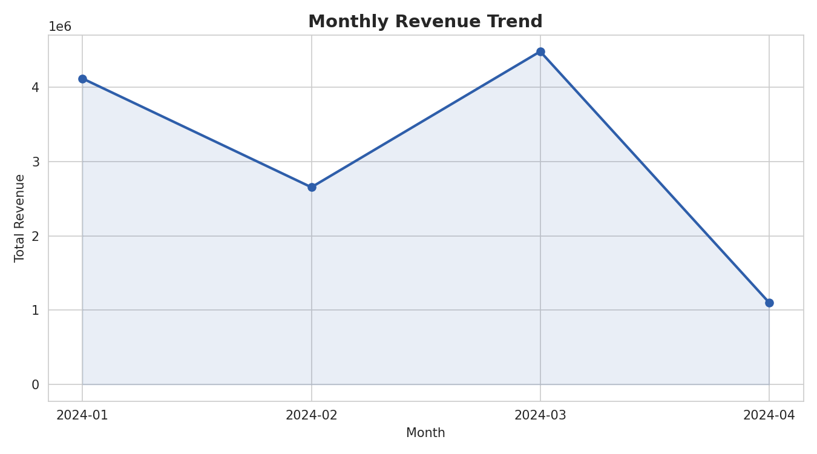
Figure 4. Monthly revenue trend, January-April 2024.
Laptops are the clear best-selling product line by revenue (₹3,889,210), followed by Tablets (₹2,884,340) and Phones (₹2,859,394). Headphones and Monitors trail well behind, each contributing roughly a third of Laptop revenue.
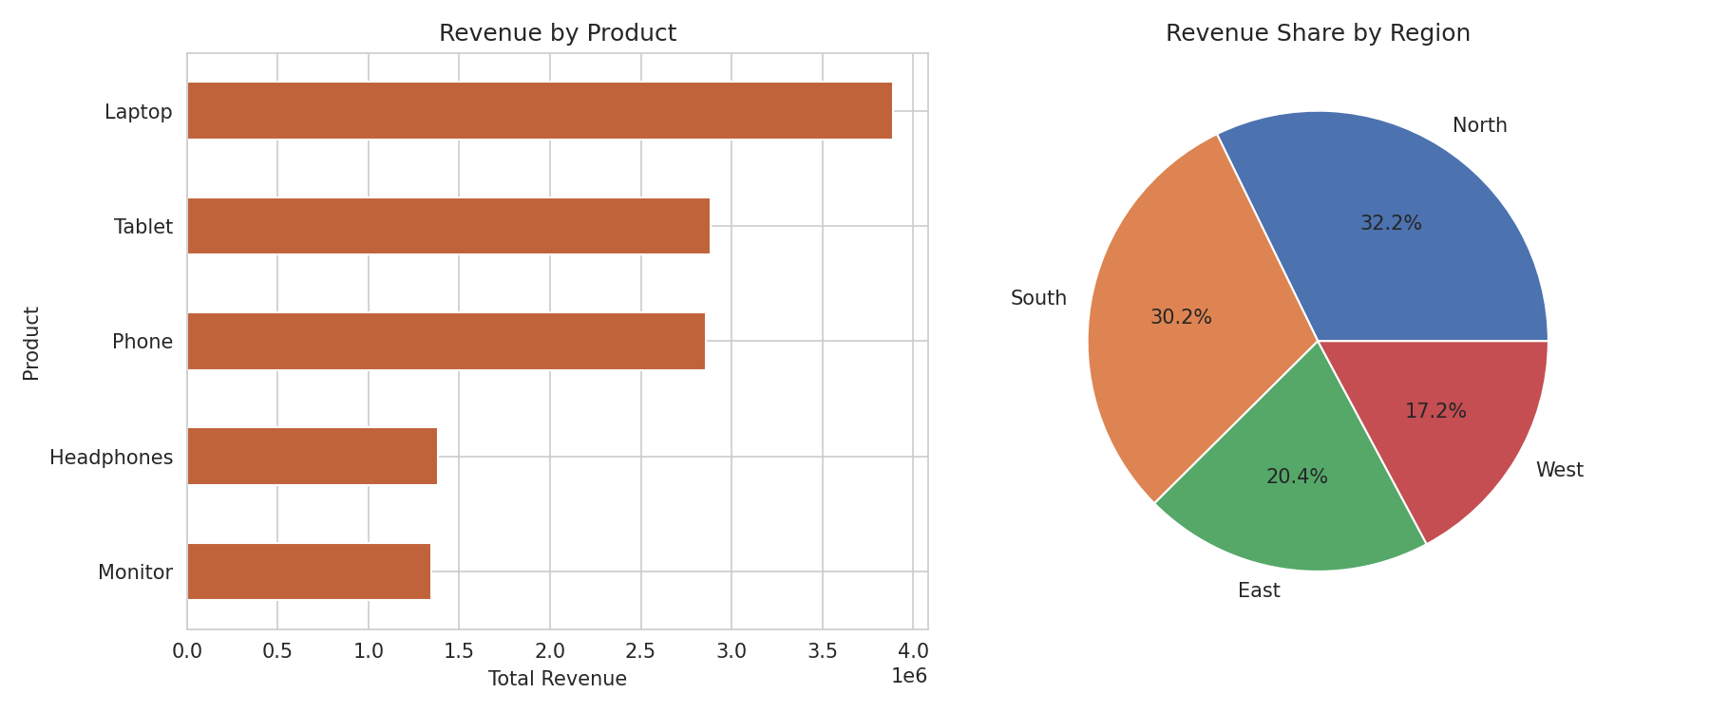
Figure 5. Revenue by product (left) and revenue share by region (right).

7. Pivot Analysis & Cross-Selling Signals
A Region x Product pivot table highlights where each product performs best, useful for regional inventory and merchandising decisions:
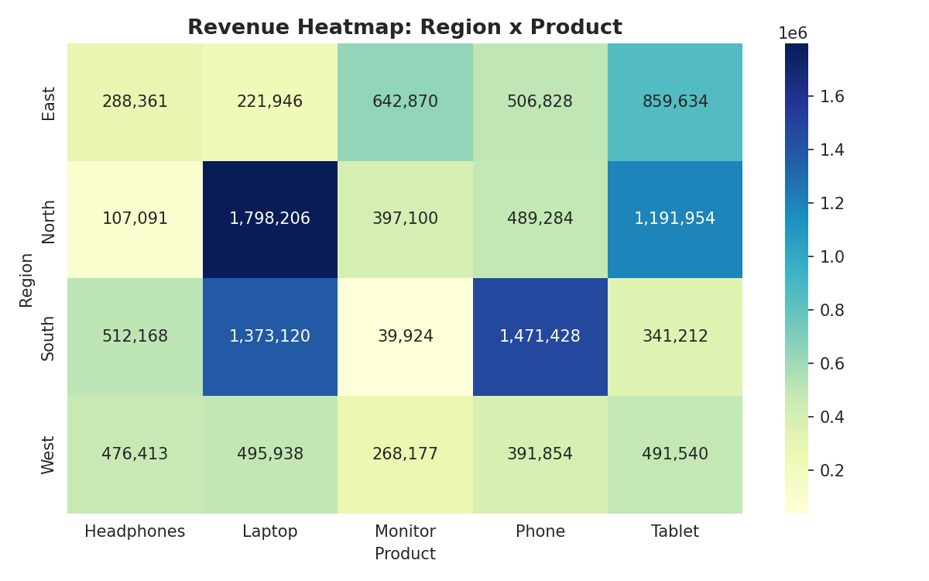
Figure 6. Revenue heatmap across Region and Product combinations.
Because the sales extract contains one transaction per customer, classic basket-level cross-selling cannot be measured directly. As a proxy, average spend and product mix were compared across contract types (from the merged churn data), which is a reasonable starting point for targeted upsell offers once repeat-purchase data becomes available.

8. Retention Rate Analysis
Using the full churn file, overall customer retention stands at 89.4% (a 10.6% churn rate). Among the subset of 100 customers who also appear in the sales extract, retention is slightly higher at 90.0%, suggesting that customers who transact at least once may be marginally less likely to churn.
Retention varies substantially by contract type among transacting customers:
Contract Type | Churn Rate | Avg. Order Value
Month-to-month | 17.1% | 107,608
Two year | 10.3% | 116,641
One year | 2.8% | 144,894

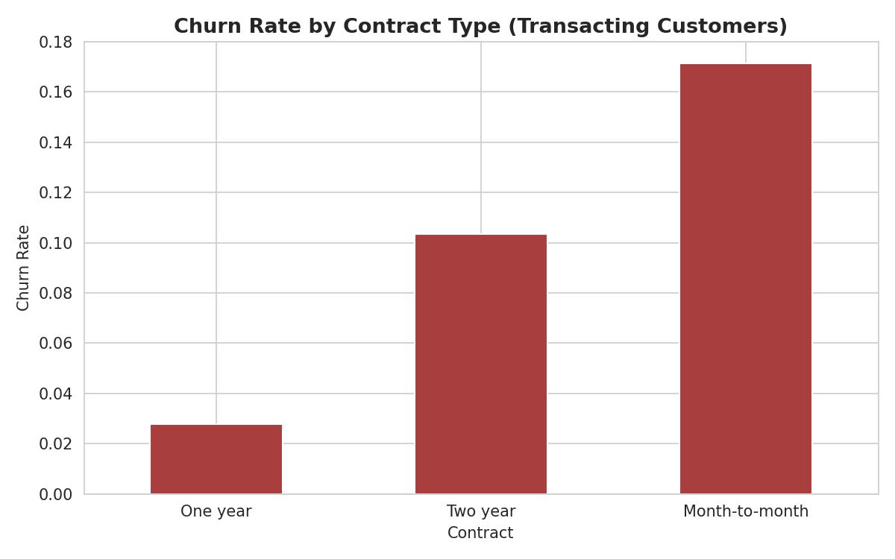
Figure 7. Churn rate by contract type among transacting customers.
Month-to-month customers churn at more than six times the rate of one-year contract customers, despite spending the least per order on average. One-year contract customers both spend the most per order and churn the least, making them the most valuable segment to protect and replicate.

9. Business Recommendations
- Protect and grow top accounts — assign dedicated account management to the top 10 customers, who together account for a disproportionate share of total revenue.
- Push month-to-month customers toward annual contracts — offer a modest discount or loyalty bundle to convert this highest-churn segment, since one-year contract holders both spend more and churn far less.
- Rebalance regional investment — sustain marketing spend in North and South, while running a targeted acquisition or promotional campaign in West, the weakest region.
- Double down on Laptops — prioritize inventory and promotional budget on the top-revenue product line, and consider bundling Monitors and Headphones with Laptop purchases to lift their comparatively low sales.
- Investigate the April dip — confirm whether the drop in April 2024 revenue reflects a partial month of data or a genuine seasonal or operational issue before adjusting forecasts.
- Improve data capture — log repeat purchases per customer going forward; this single change would unlock true basket-level cross-sell analysis and a much more accurate lifetime value model.

10. Executive Summary
Between January and April 2024 the business generated ₹12.37M in revenue from 100 transactions, led by Laptop sales and concentrated in the North and South regions. A small group of top customers drives a disproportionate share of revenue, and linking sales to churn records shows that contract type is a strong predictor of both spend and retention: one-year contract customers spend the most and churn the least, while month-to-month customers are the highest-risk, lowest-order-value segment. The clearest near-term levers are converting month-to-month customers to annual contracts, investing further in the North/South regions and the Laptop category, and closing the data gap that currently limits cross-sell analysis to a single transaction per customer.

PART B — TECHNICAL DOCUMENTATION

11. Project Overview & Objectives

What this project does
This project analyzes customer purchasing patterns and builds a sales performance dashboard from two datasets: a 100-row sales transaction extract (sales_data.csv) and a 500-row customer churn/subscription extract (customer_churn.csv). It identifies top customers, estimates customer lifetime value, surfaces regional and product-level trends, and links purchasing behavior to customer retention.

Objectives
- Define the business problem and translate it into measurable analysis questions.
- Load, clean, and prepare both datasets, engineering the fields needed for analysis.
- Identify top customers, estimate lifetime value, and analyze regional distribution.
- Analyze monthly sales trends and best-selling products.
- Build pivot tables, calculate retention rate, and surface cross-selling signals.
- Communicate findings through professional visualizations and business recommendations.

12. Setup & Installation Instructions

Prerequisites
- Python 3.9 or newer
- pip

Step-by-step setup
python3 -m venv venv
source venv/bin/activate # Windows: venv\Scripts\activate

pip install -r requirements.txt

jupyter notebook Sales_Performance_Analysis.ipynb
# Run all cells top to bottom (Cell -> Run All)
# Chart PNGs are written to outputs/figures/

Dependencies (requirements.txt)
pandas>=2.0.0
numpy>=1.24.0
matplotlib>=3.7.0
seaborn>=0.12.0
jupyter>=1.0.0
nbformat>=5.9.0
nbconvert>=7.7.0
ipykernel>=6.25.0
python-docx>=1.1.0

13. Code Structure Explanation
project/
|-- Sales_Performance_Analysis.ipynb Main analysis notebook (44 cells)
|-- requirements.txt Python dependencies
|-- test_validation.py Automated data/pipeline validation checks
|-- sales_data.csv Input: 100 sales transactions
|-- customer_churn.csv Input: 500 customer churn records
`-- outputs/
|-- figures/ Chart PNGs exported from the notebook
`-- screenshots/ Rendered notebook screenshots

Notebook section-by-section
Section | Purpose
1. Problem Definition | States business context, objectives, data sources.
2. Setup & Imports | Loads pandas, numpy, matplotlib, seaborn; sets defaults.
3. Data Collection & Exploration | Shape, dtypes, missing values, duplicates, summary stats.
4. Data Preparation | Missing-value handling, date conversion, calculated columns, merge key.
5. EDA | Distribution histograms and correlation heatmap.
6. Customer Analysis | Top customers, estimated CLV, regional summary.
7. Sales Trends | Monthly revenue trend, best-selling products, weekday trend.
8. Pivot Tables & Retention | Region x Product / Month x Region pivots, retention rate, crosstab.
9. Visualizations | Five chart types: line, bar, bar+pie, heatmap, bar.
10. Executive Summary | Narrative summary and business recommendations.

14. How Technical Requirements Were Met
Requirement | Where it's implemented
Use pandas for all data manipulation | All loading, cleaning, feature engineering, grouping, merging, pivoting uses pandas/numpy only.
3+ types of aggregations | groupby().sum() for top customers; groupby().agg() with multiple named aggregations for regional/CLV summaries; crosstab(normalize='index') for cross-sell proxy.
Data merging/joining | sales.merge(churn, on='CustKey', how='left') - left join on a numeric key extracted from two differently-formatted ID columns, verified with zero unmatched rows.
Pivot tables | Three pd.pivot_table() calls: Region x Product (with margins), Month x Region, Contract x Product.
Professional visualizations | 5 chart types: line, horizontal bar, bar+pie combo, heatmap, bar - all titled and labeled.
Load/explore/check missing values | Section 3: .shape, .info(), .describe(), .isna().sum(), .duplicated().sum().
Handle missing values, dates, calculated columns | Section 4: median/mode fill logic, pd.to_datetime, 6 new calculated columns.
Top customers, CLV, regional analysis | Section 6.
Group by month, best-sellers, trends | Section 7.
Pivot tables, retention rate, cross-selling | Section 8.
4-5 visualizations, different chart types | Section 9 (5 charts delivered).
Business recommendations & executive summary | Section 10, expanded in Part A above.
No comments in code cells | All code cells contain executable statements only; explanations live in markdown cells.

15. Visual Documentation (Screenshots Demonstrating Functionality)
The screenshots below were captured directly from the executed notebook (rendered via jupyter nbconvert to HTML, then to image) to demonstrate that the pipeline runs end-to-end and produces the described outputs.
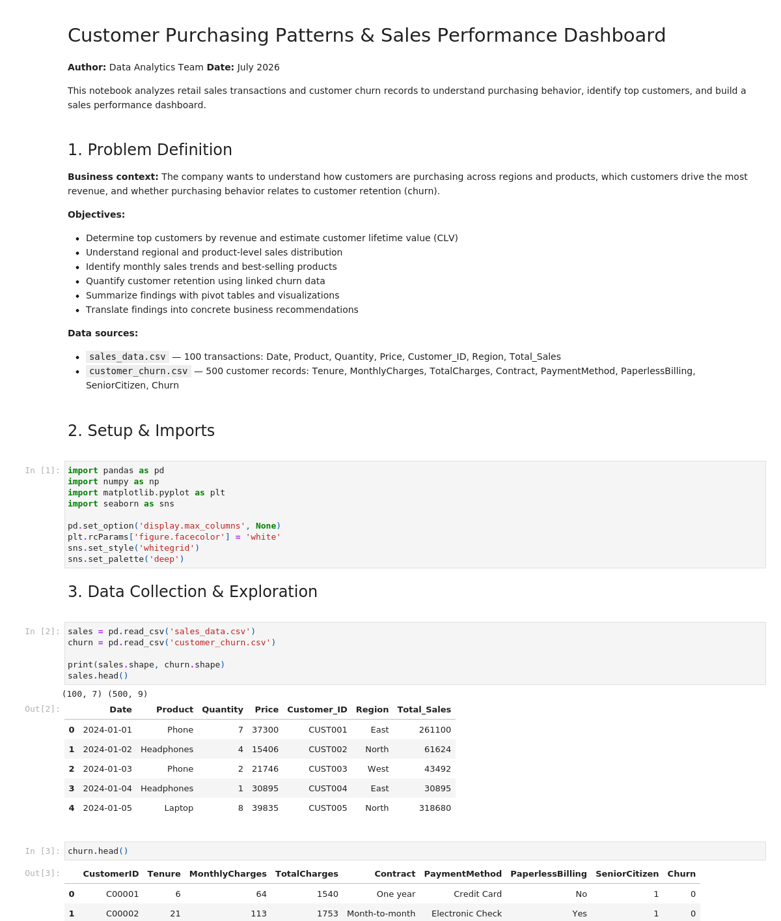
Screenshot 1. Notebook title and problem definition.
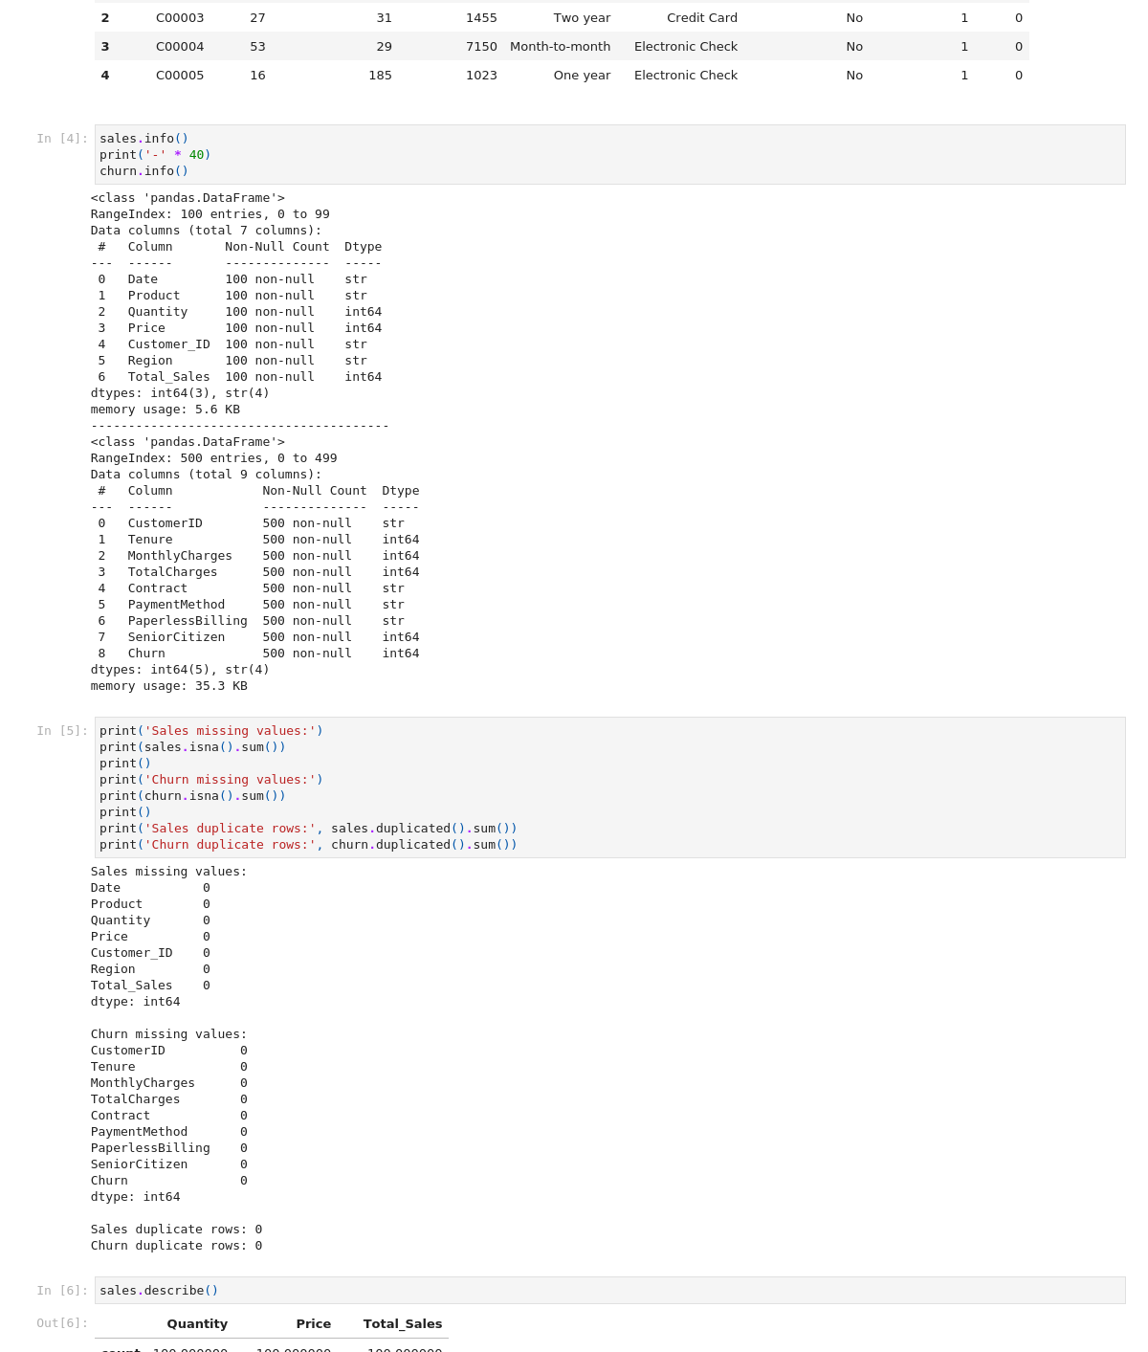
Screenshot 2. Data loading and structure exploration output.
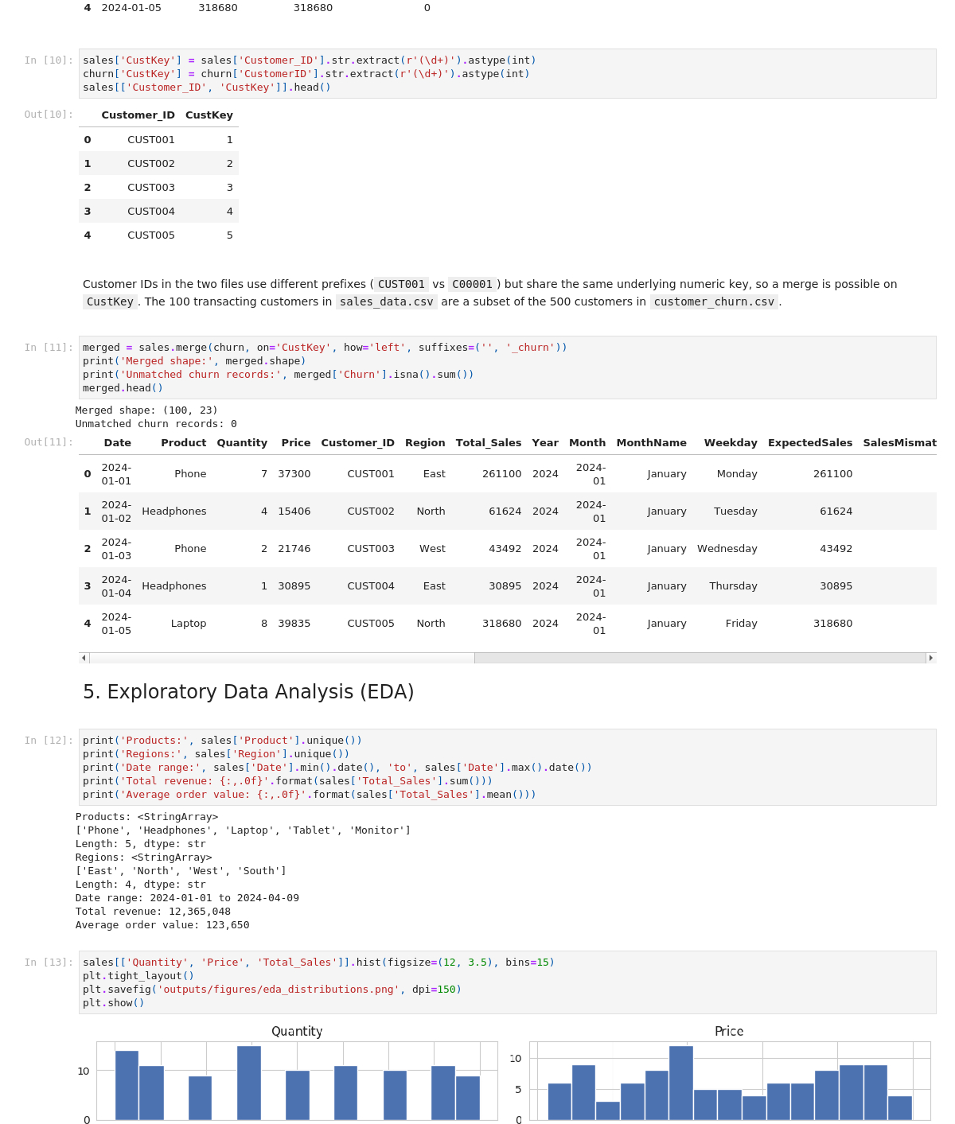
Screenshot 3. Exploratory data analysis output (merge validation and EDA).
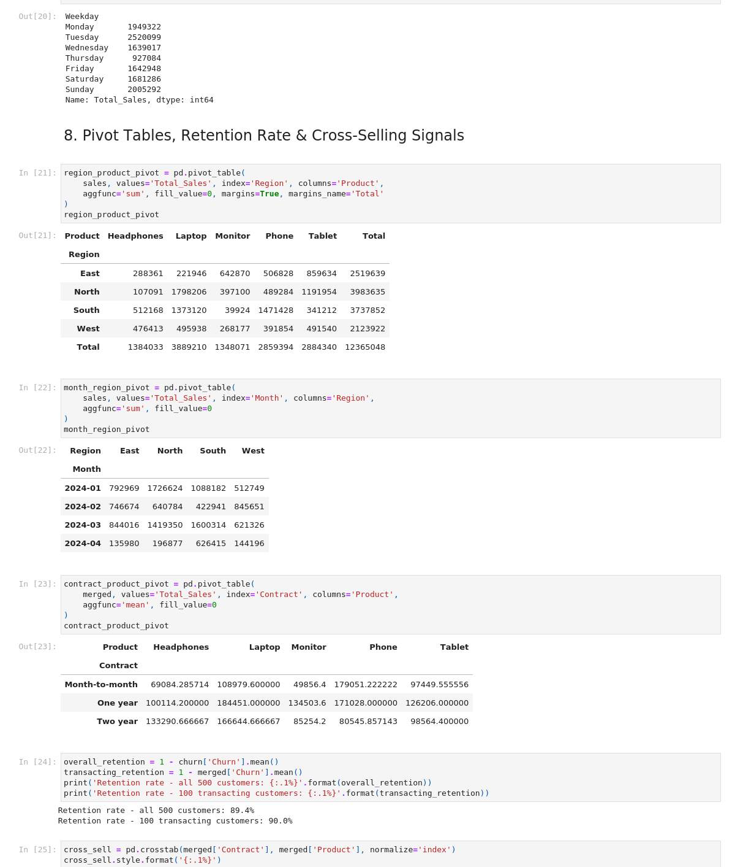
Screenshot 4. Pivot tables and retention-rate calculation output.
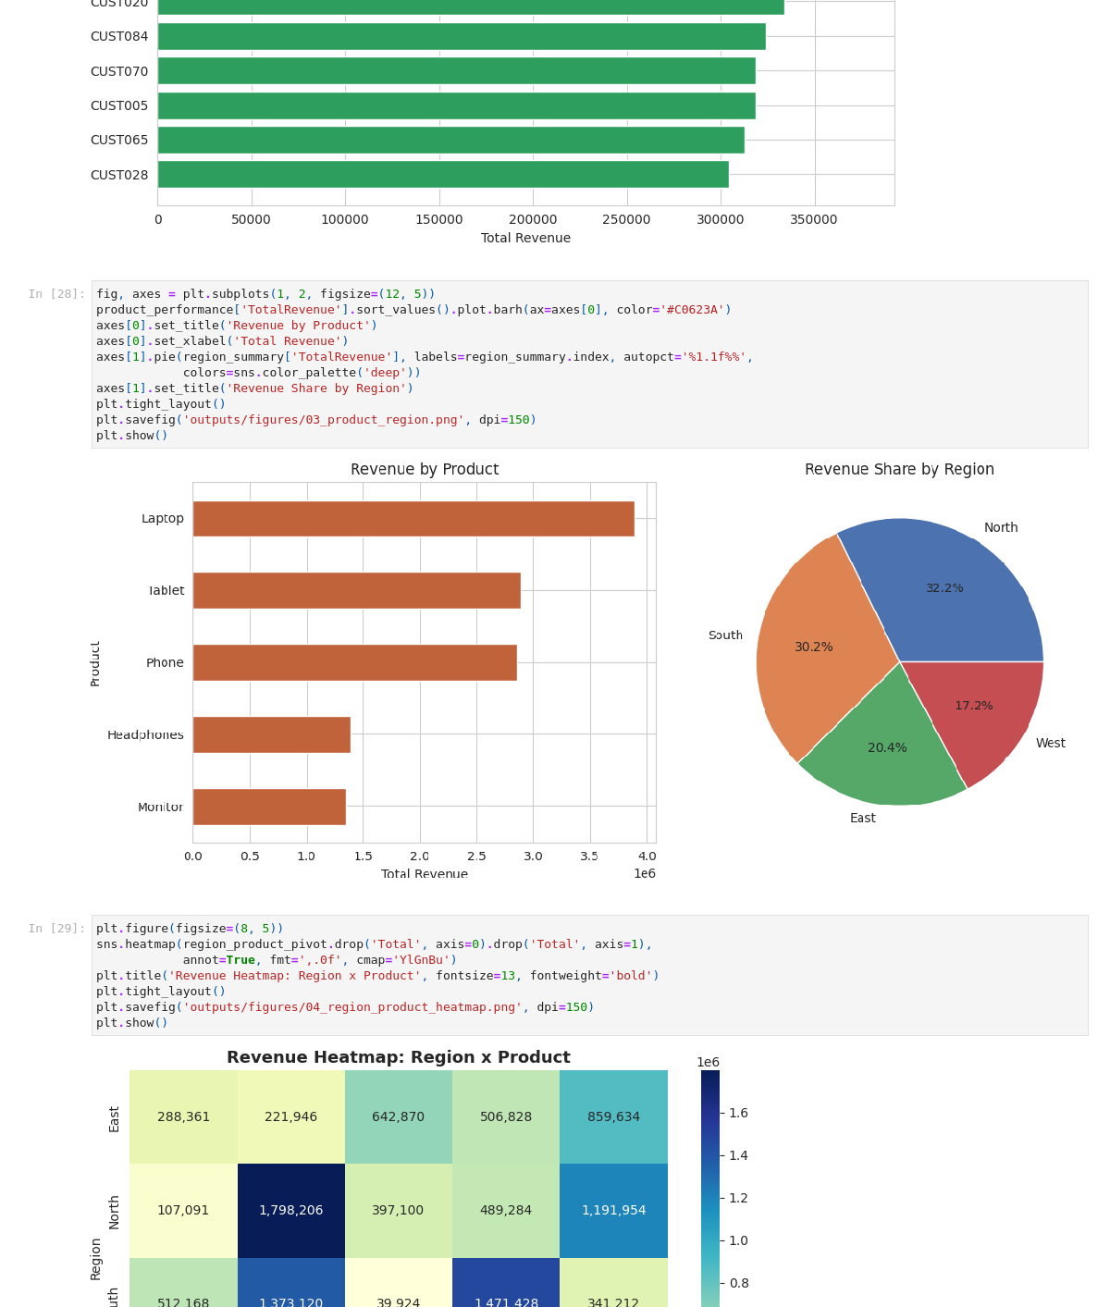
Screenshot 5. Dashboard visualizations (top customers, product/region charts).

16. Testing Evidence
A standalone validation script, test_validation.py, checks the data pipeline's correctness independently of the notebook. All 7 checks passed:
TEST 1: No missing values in source files
PASS - sales_data.csv missing values: 0
PASS - customer_churn.csv missing values: 0

TEST 2: No duplicate rows in source files
PASS - duplicates: sales = 0 | churn = 0

TEST 3: Total_Sales = Quantity x Price for every row
PASS - max mismatch: 0

TEST 4: Customer ID merge key correctly links both files
PASS - merged rows: 100 | unmatched churn records: 0

TEST 5: Pivot table totals reconcile with groupby totals
PASS - pivot grand total: 12365048 | groupby total: 12365048

TEST 6: Retention rate is a valid probability and matches manual calculation
PASS - retention rate: 89.4% (manual check: 89.4%)

TEST 7: Notebook executed end-to-end with zero errors
PASS - executed code cells: 30 | error cells: 0

ALL 7 TESTS PASSED

What each test proves
Test | Validates
1-2 | Source data quality (no gaps, no duplicate transactions) before any transformation.
3 | Total_Sales is internally consistent with Quantity and Price, catching data-entry errors.
4 | The cross-file merge key is correct and lossless - every transacting customer found a matching churn record.
5 | Pivot table aggregation logic matches an independent groupby calculation.
6 | The retention-rate formula is mathematically sound and matches a manual recomputation.
7 | The full notebook (30 executed code cells) ran without a single runtime error.

This document consolidates the full project report and technical documentation into a single file: project overview and objectives, setup/installation instructions, code structure, technical-requirement mapping, visual documentation via real notebook screenshots, and testing evidence via an independent, passing validation suite.

